**Question 3:**

**Answer:**

1 & 2: Output, Created a repository.

<https://github.com/gurramnaresh2605/ABC1611>

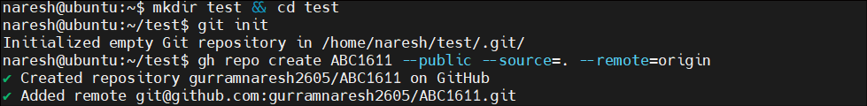

3.Output: Created a VM1(Public IP) and VM2(Private IP) and did the peering.

Also capture the Public and Private IP addresses as Ouput.

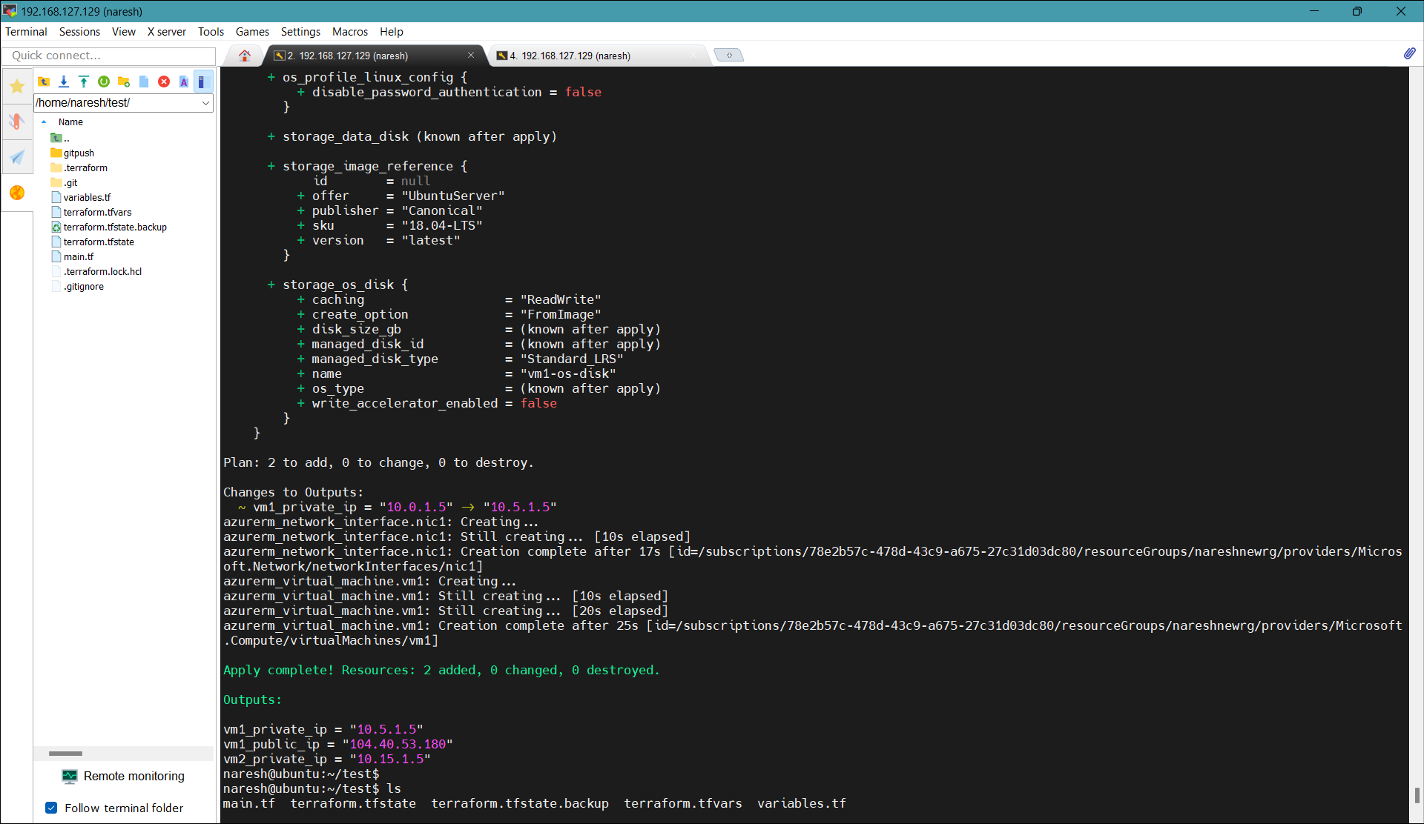

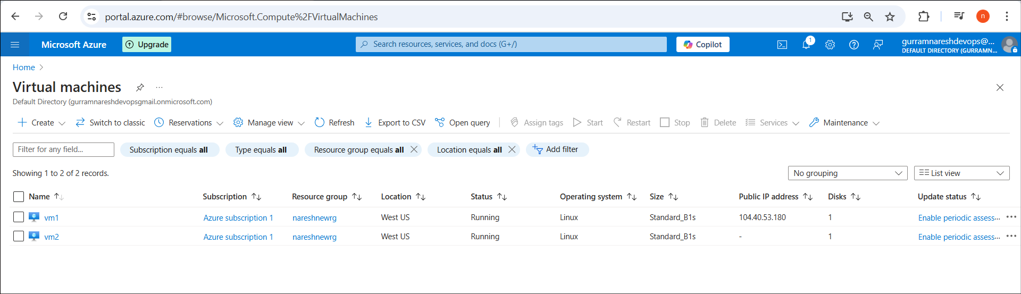

Created VNets with mention IP Address spaces. 10.5.0.0/16 and 10.15.0.0./16

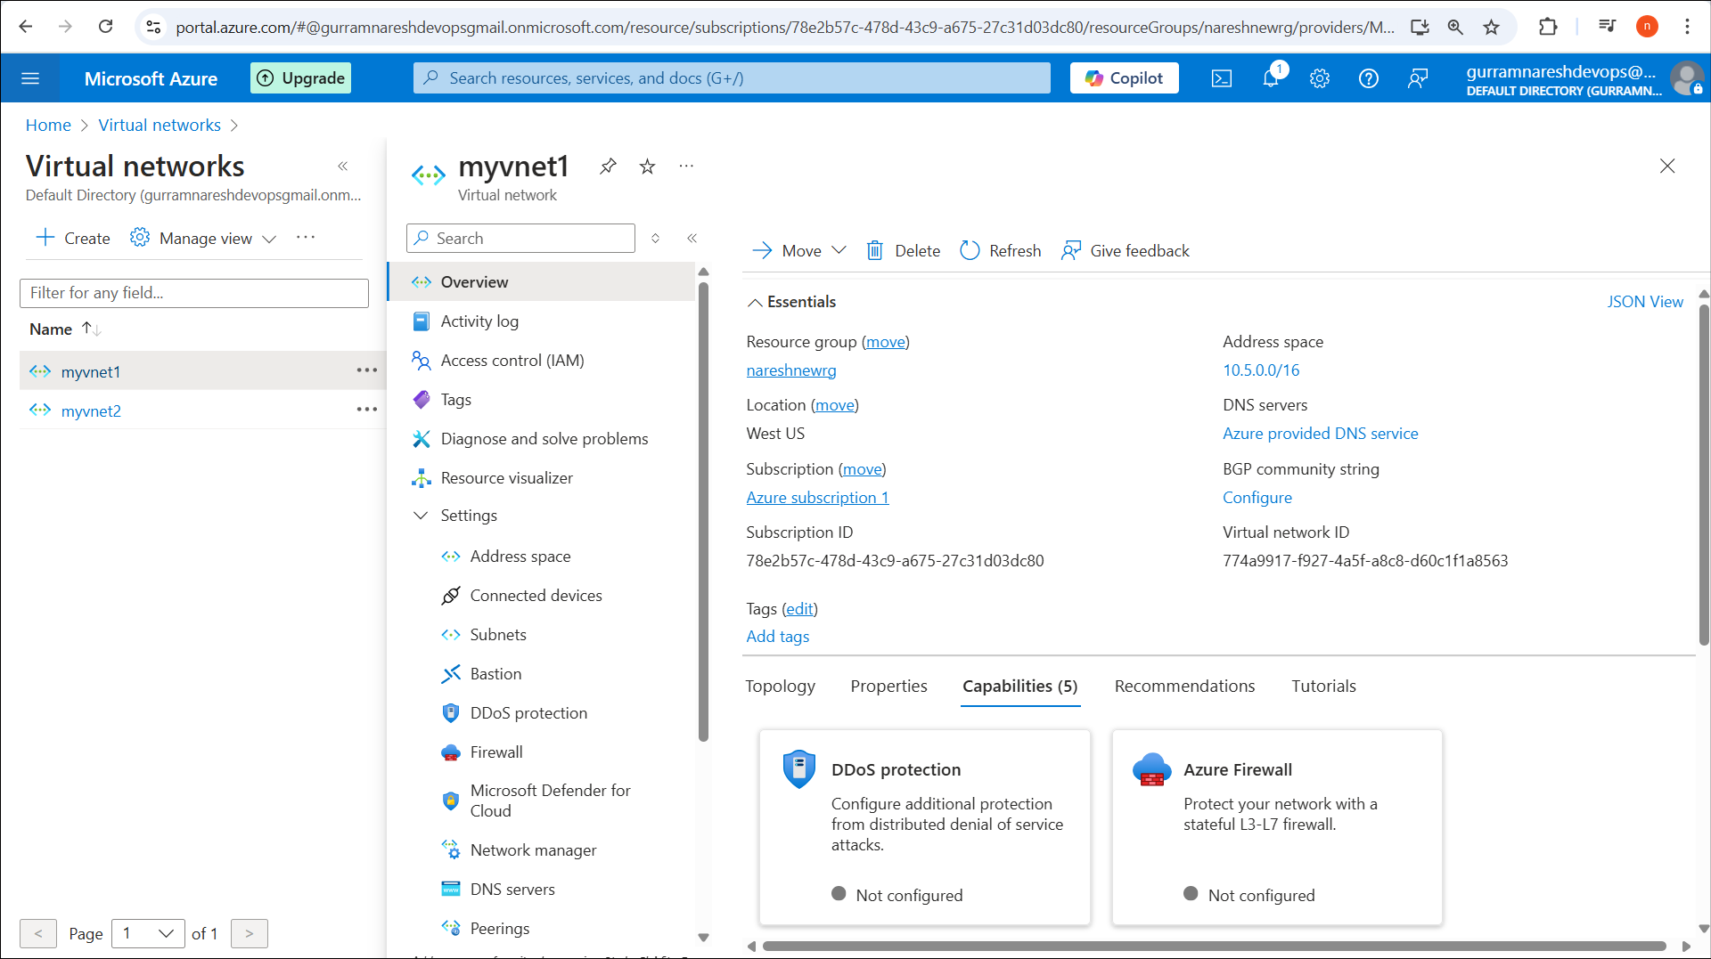

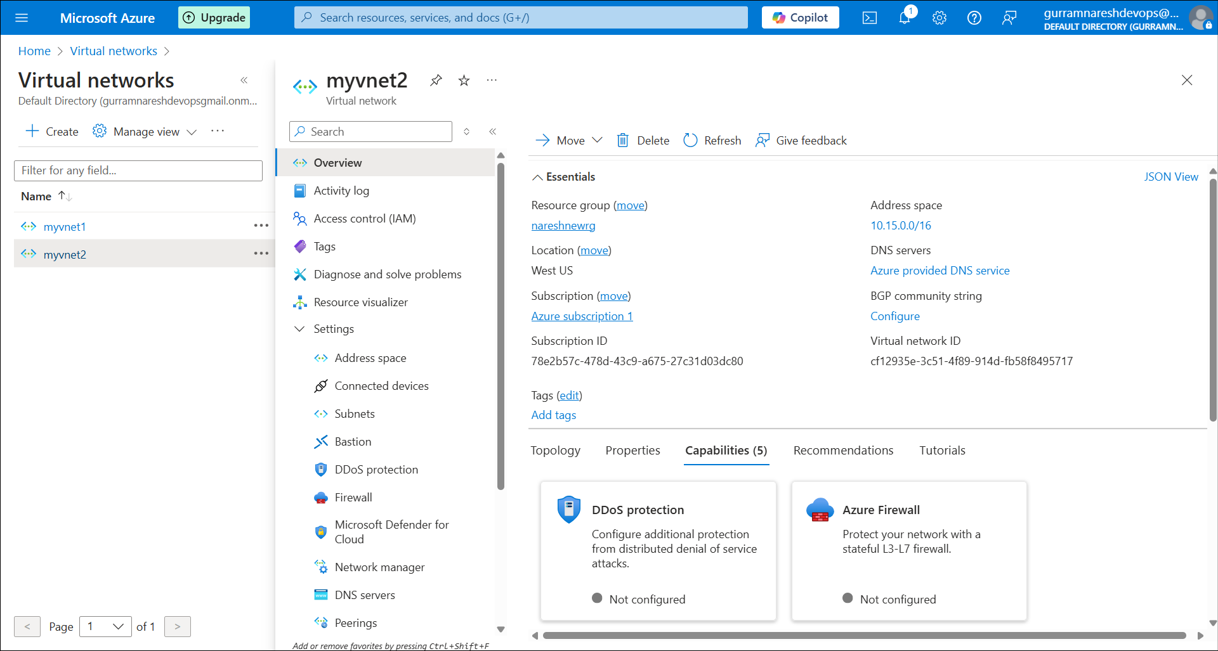

Also done the peering.

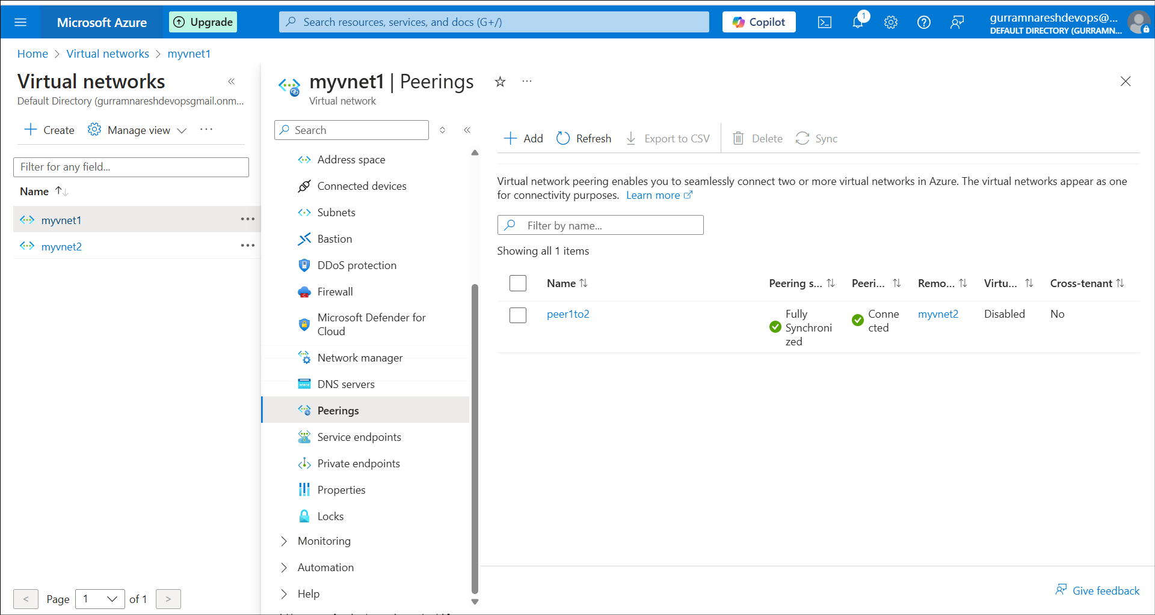

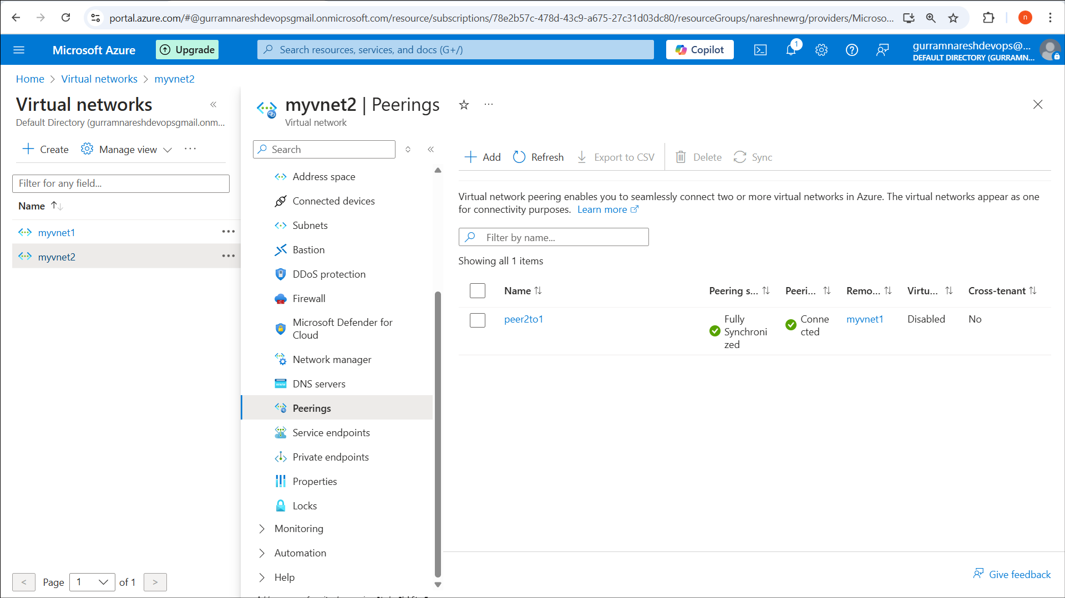

**4. Check in these scripts to git hub**

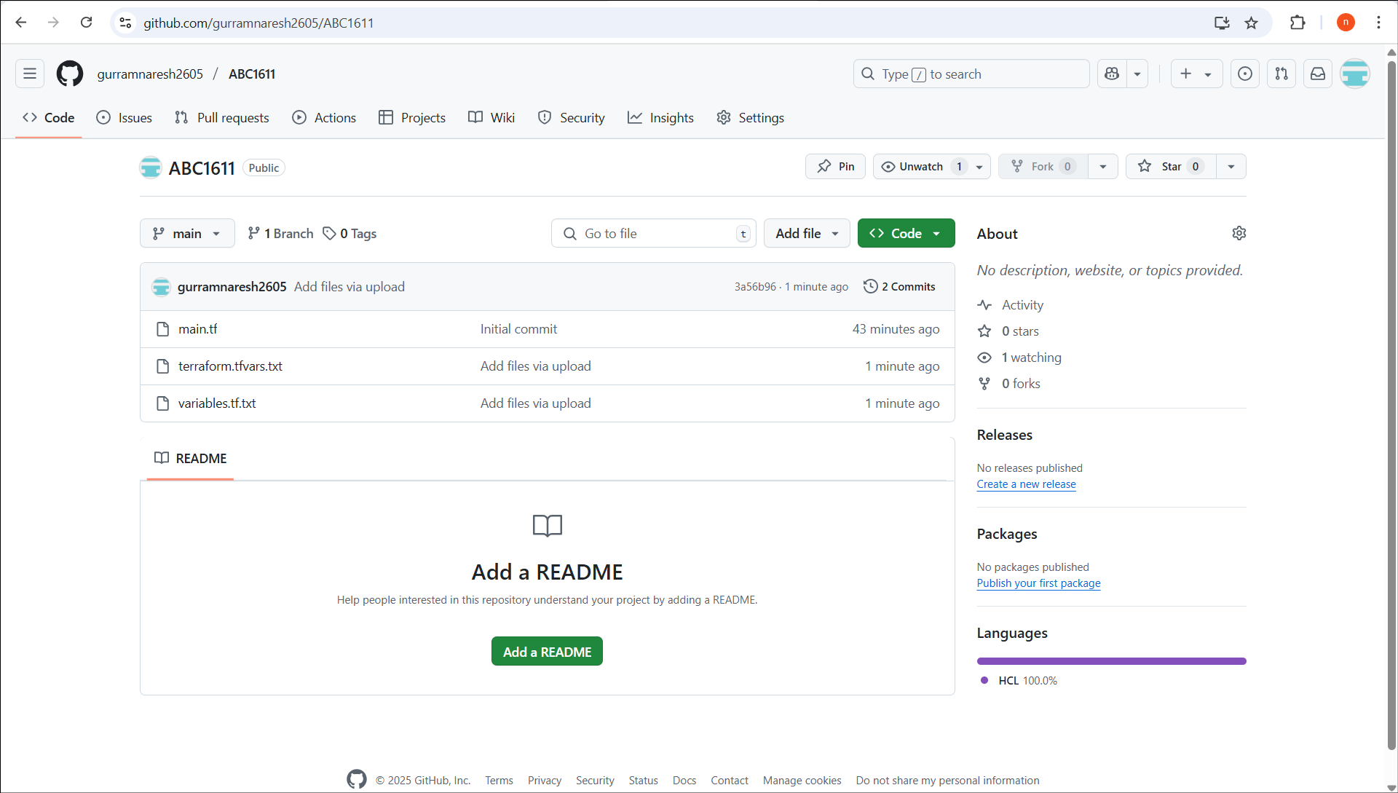

5. Create a different folder and create a tf script with github repository as a module source.

Created a github repository as a module source :

<https://github.com/gurramnaresh2605/terraform-test.git>

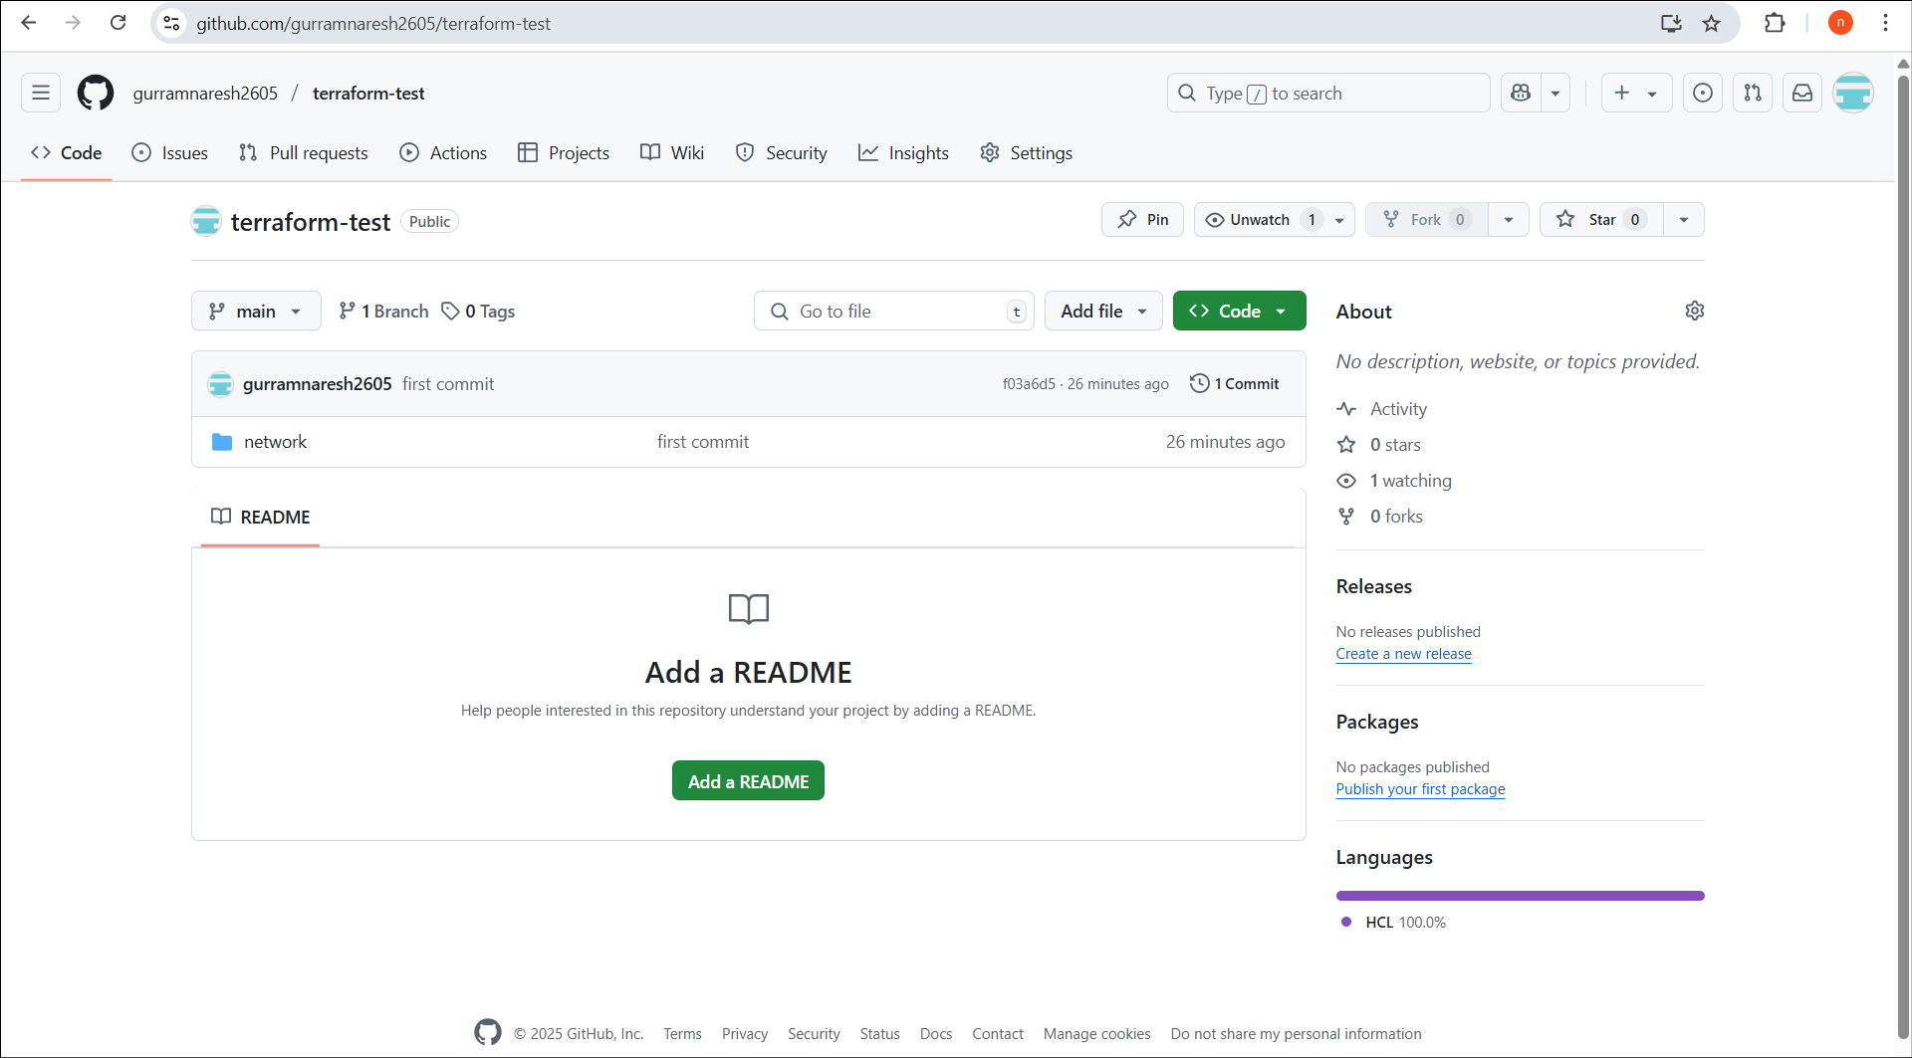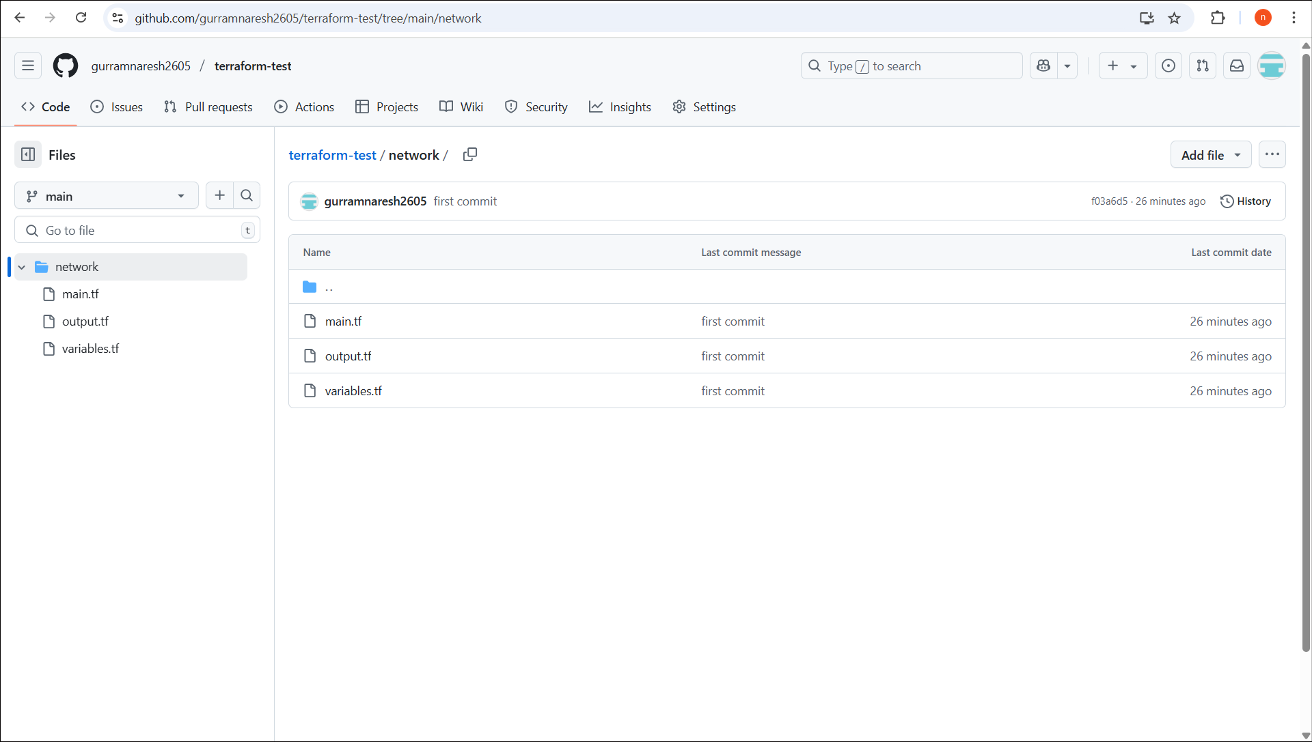

**Output:**

